Practical-7:
Aim:
To implement queue using array and linked list, and apply queue-based logic to number
generation, and structure simulation problems.
Problem 1
A government office has a token counter that issues tokens to visitors. The counter can hold at
most n tokens at a time. New visitors join from one end and are served from the other end in the
order they arrived. If the counter is full, no new token can be issued, and if it is empty, no one
can be served. Given a sequence of join and serve operations, implement this fixed-capacity
token system and print the current front token after each operation. Report an error if an
operation cannot be performed.
Describe how your solution tracks the front and rear of the queue. What happens to your front
and rear pointers over time as join and serve operations keep happening, and does your
solution handle the case where space appears to run out even though slots have been freed?
Problem 2
A hospital emergency ward receives patients continuously and attends to them strictly in the
order they arrived, with no upper limit on how many can be waiting at once. New patients are
added at the back and the doctor always attends to the patient at the front. Given a sequence of
arrive and attend operations, implement this unlimited patient queue and print the current front
patient after each operation.
Describe how your solution differs from Problem 1 in how it manages capacity. What happens in
your solution when the attend operation is called on an empty ward with no patients waiting?
Practical-Link:
https://github.com/kahanipatel156-dev/FDSA-Batch-B/upload/main/Practical-7

Screenshots:
Problem 1:
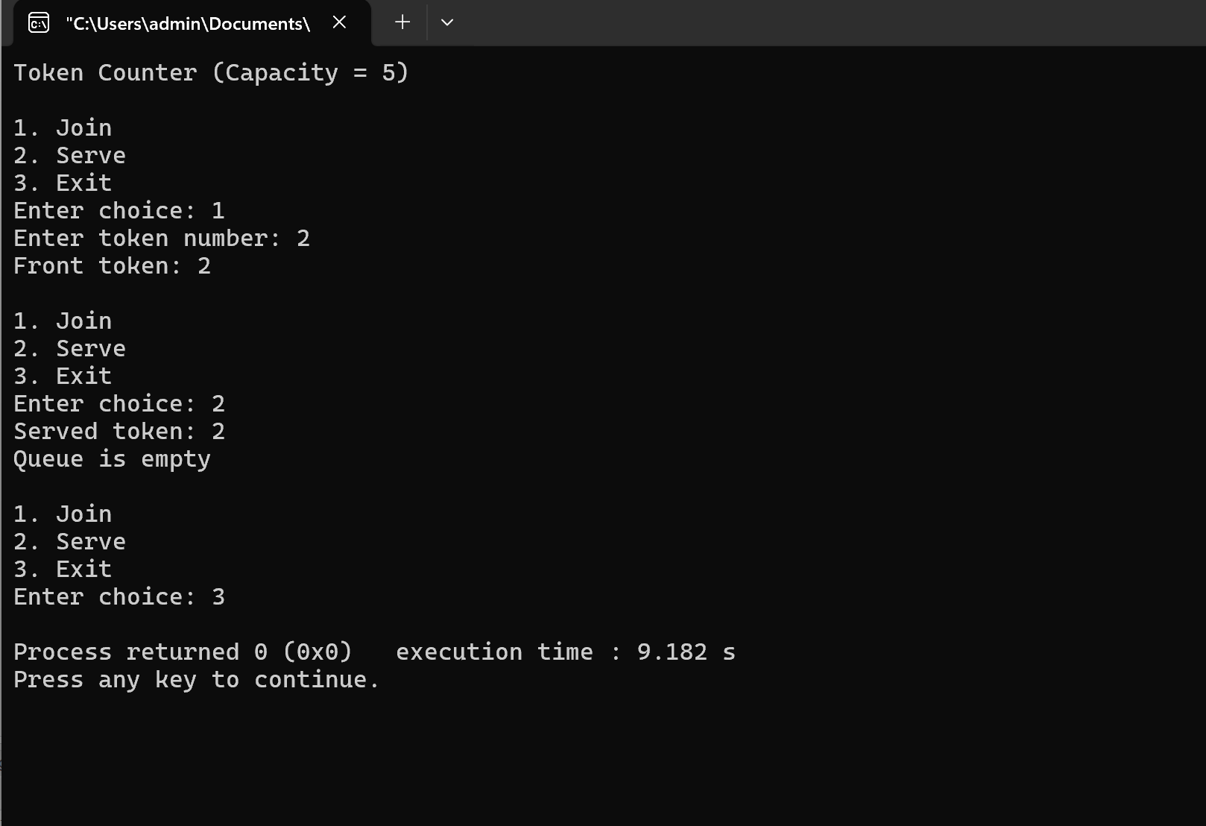
Problem 2:
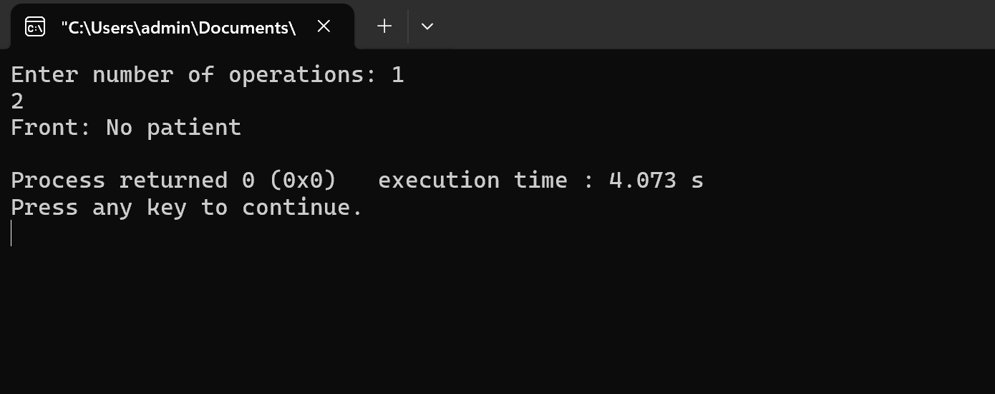

Problem-Faced:
in making the concepts and applying it to the code.
Learning:
Concepts of queue implementation in the code.

